**Write a blog on Difference between HTTP1.1 vs HTTP2:**

-ABOUT HTTP

-HTTP VERSION

-HTTP1.1VS HTTP2.0

-MAJOR ADVANTAGE OF HTTP2.0 OVER HTTP 1.1

**HTTP (HyperText Transfer Protocol):**

* It is a protocol used to access the data on the World Wide Web (www).
* The HTTP protocol can be used to transfer the data in the form of plain text, hypertext, audio, video, and so on.
* This protocol is known as HyperText Transfer Protocol because of its efficiency that allows us to use in a hypertext environment where there are rapid jumps from one document to another document.

**HTTP PROTOCOL VERSION:**

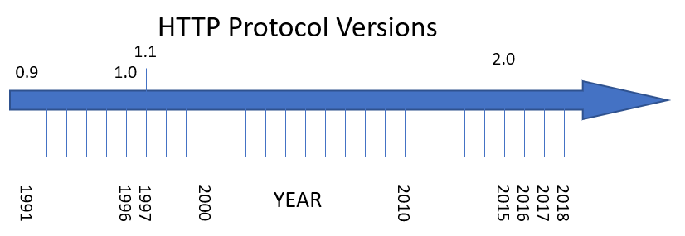

**DIFFERENCE BETWEEN HTTP1.1VS HTTP2.0**

|  |  |
| --- | --- |
| HTTP 1.1 | HTTP2.0 |
| It works on the textual format. | It works on the binary protocol |
| There is head of line blocking that blocks all the requests behind it until it doesn’t get its all resources. | It allows multiplexing so one TCP connection is required for multiple requests |
| It uses requests resource Inlining for use getting multiple pages | It uses PUSH frame by server that collects all multiple pages |
| It compresses data by itself. | It uses HPACK for data compression |

**The major advantages of HTTP 2.0 over HTTP 1.1 include the following :**

Higher loading speed

Improvement of web positioning

Automatic prioritization

Less broadband consumption

Immediate presentation